1.2.1 A discrete-time system may be classified as follows:

• memoryless/with memory

• causal/noncausal

• linear/nonlinear

• time-invariant/time-varying

• BIBO stable/unstable

Classify each of the following discrete-times systems.

(a) y(n) = cos(x(n)).

Memoryless , causal, nonlinear, time-invariant, BIBO stable

(b) y(n) = 2n 2 x(n) + nx(n + 1).

with memory, noncausal, nonlinear, time-invariant, unstable

(c) y(n) = max {x(n), x(n + 1)}

Note: the notation max{a, b} means for example; max{4, 6} = 6.

with memory, noncausal, nonlinear, time-invariant, BIBO stable

(d) y(n) = x(n) when n is even

= x(n − 1) when n is odd

with memory, causal, nonlinear, time-varying, BIBO stable

1.2.2 A discrete-time system is described by the following rule

y(n) = 0.5x(2n) + 0.5x(2n − 1)

where x is the input signal, and y the output signal.

1. Sketch the output signal, y(n), produced by the 4-point input signal, x(n) illustrated below.

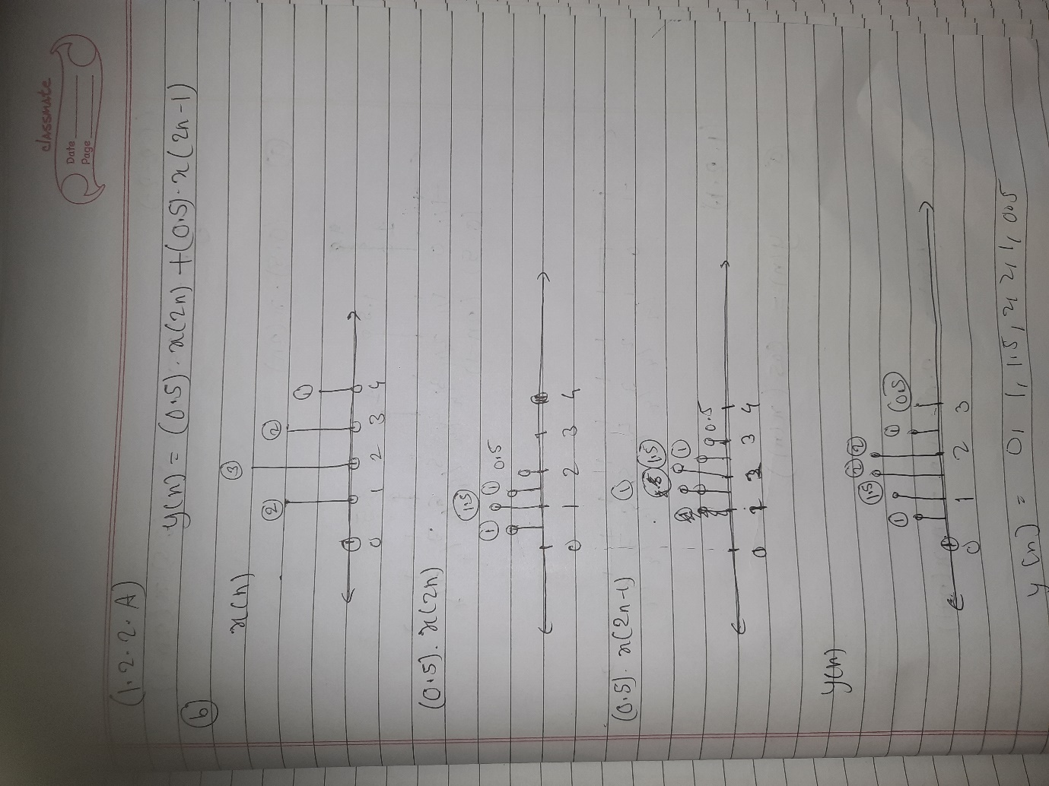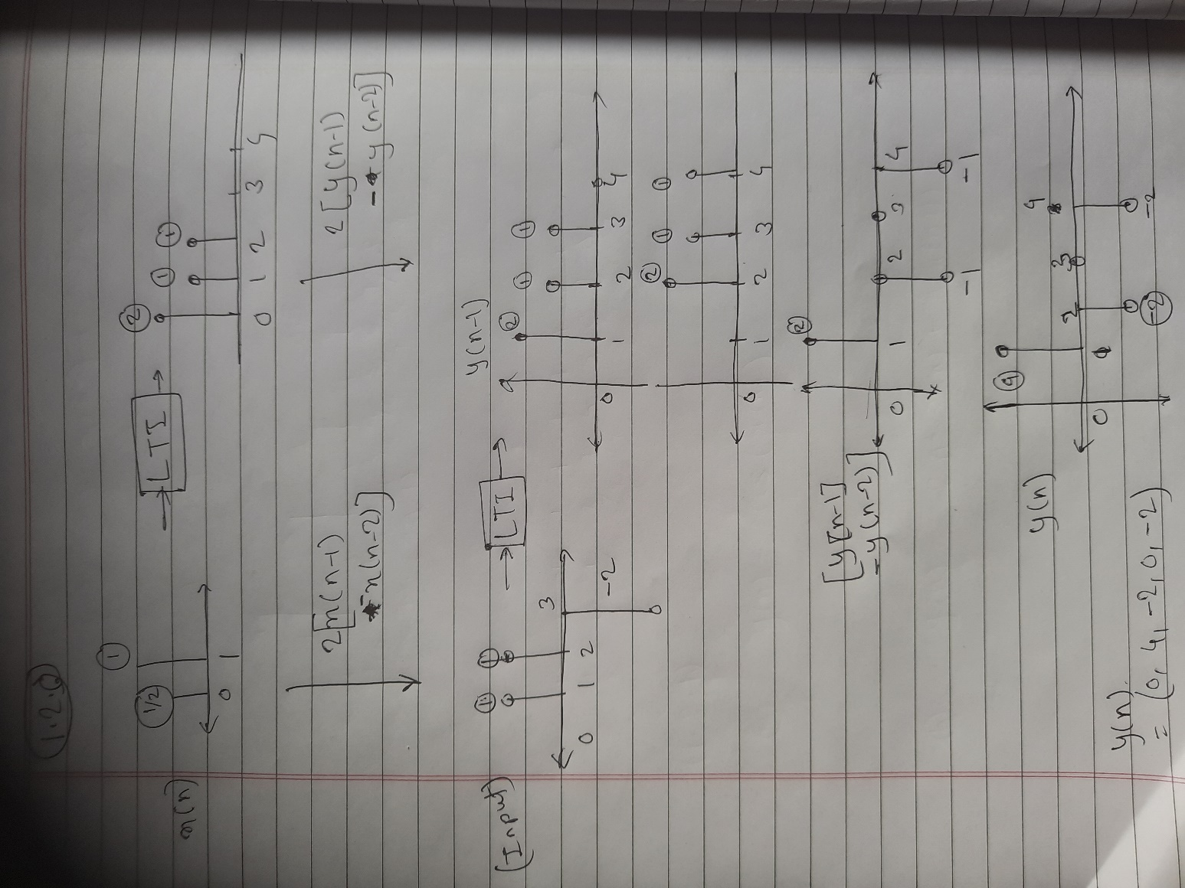

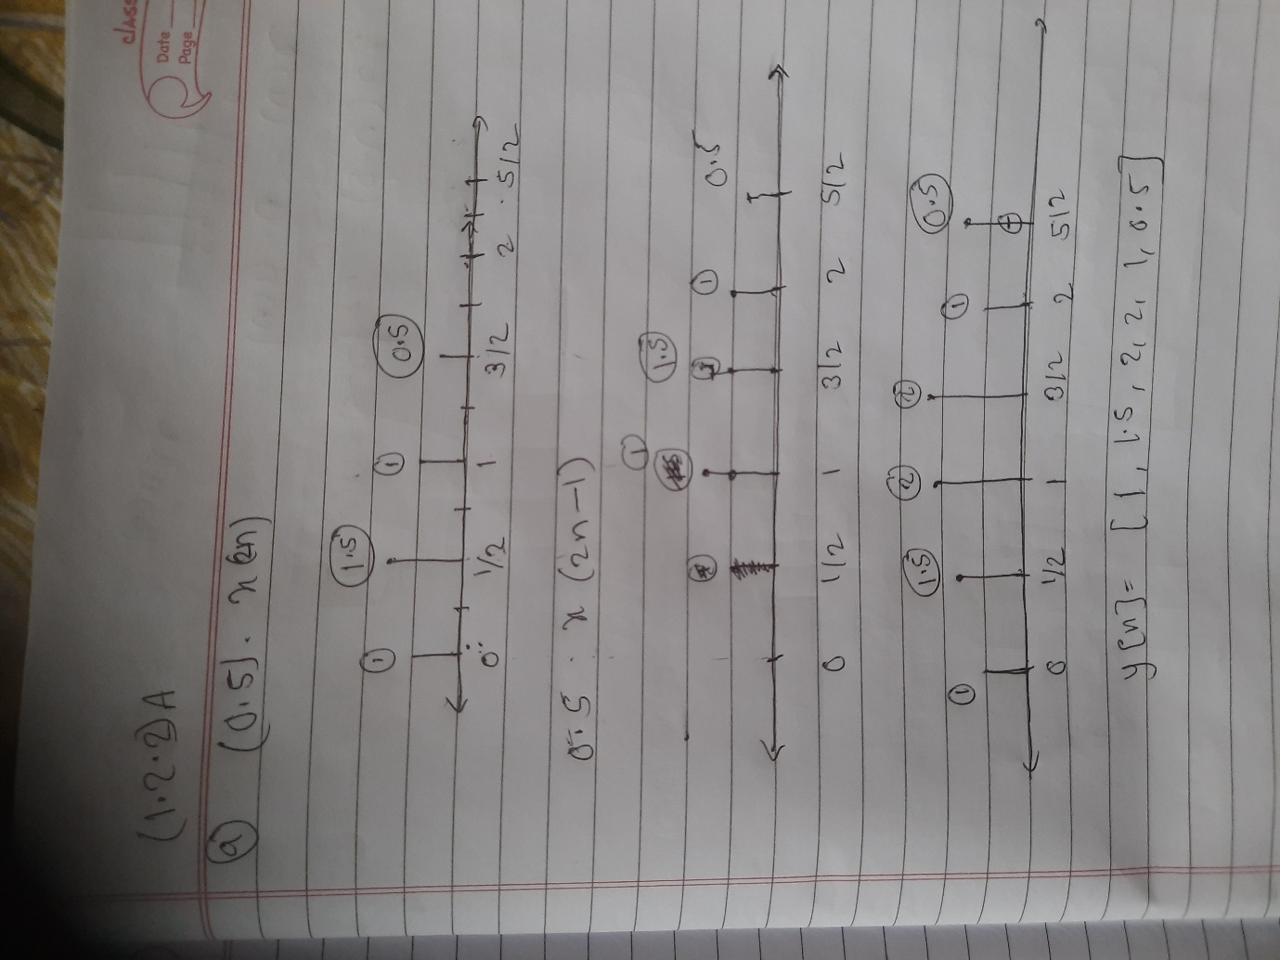

(b) Sketch the output signal, y(n), produced by the 4-point input signal, x(n) illustrated below.

(c) System Classification:

i. causal

ii. linear

iii. time-varying